**Github URL** : <https://github.com/Sravanthi427/Phase-1_Project/tree/master/project_phase1>

**Project Description:**

LockedMe.com is a project proposed by Company Lockers Inc, this is a prototype application various operations will be performed by user via command line.

Below are the features and operations of the application:

* Retrieve file names listed in root directory in ascending order
* Business-level Operations:
  + Option to add a user specified file to the application
  + Option to delete a user specified file to the application
  + Option to search a user specified file to the application
  + Navigation option to close the current execution context and return to the main context
* Option to close the application

For this project, I used Atlassian JIRA software tool to plan my work in two Sprints. The Duration of each Sprint is about a week. I created user stories for each feature of the application and planned to be executed in Sprint 1 and Sprint 2.

Sprint Planning:

**Sprint 1:**

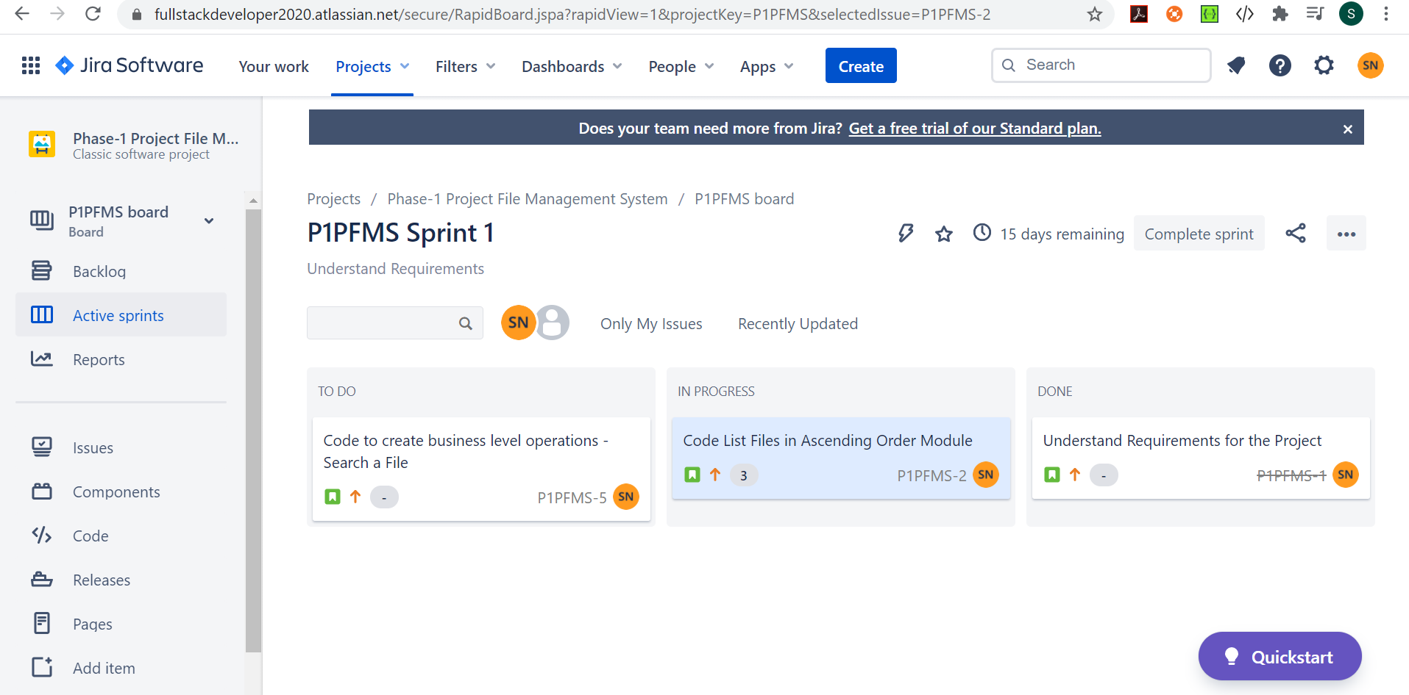

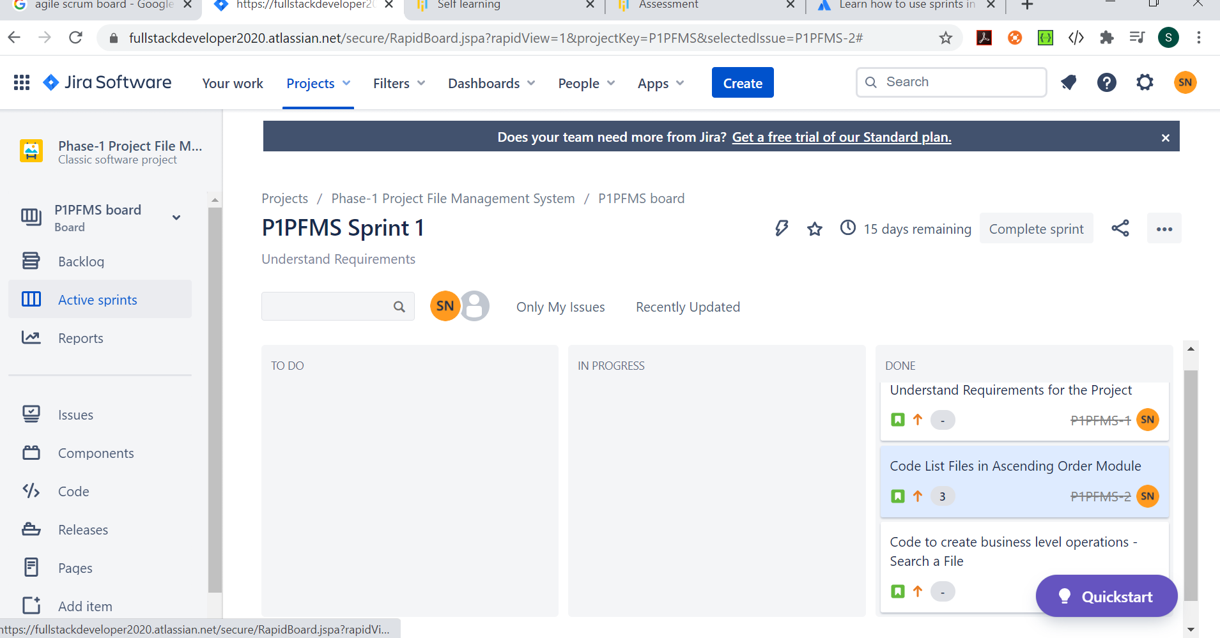

**Sprint 2:**

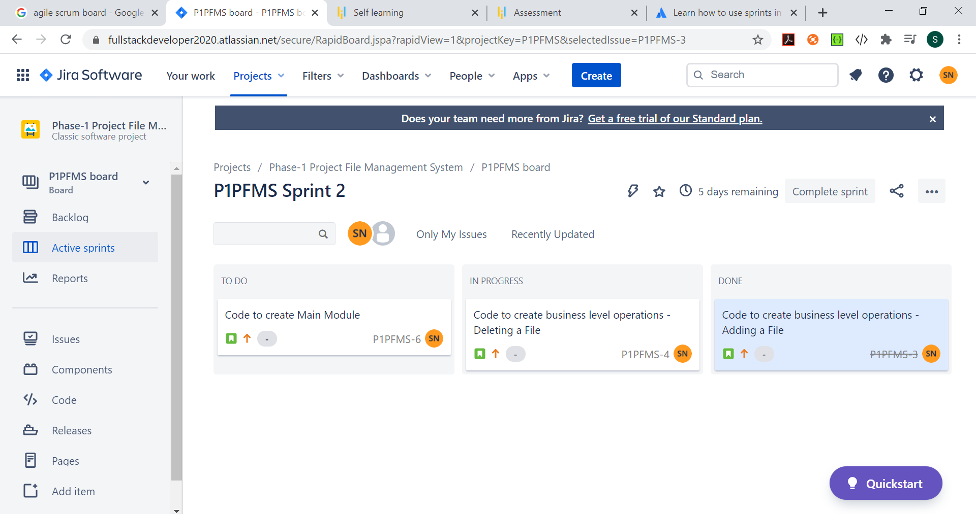

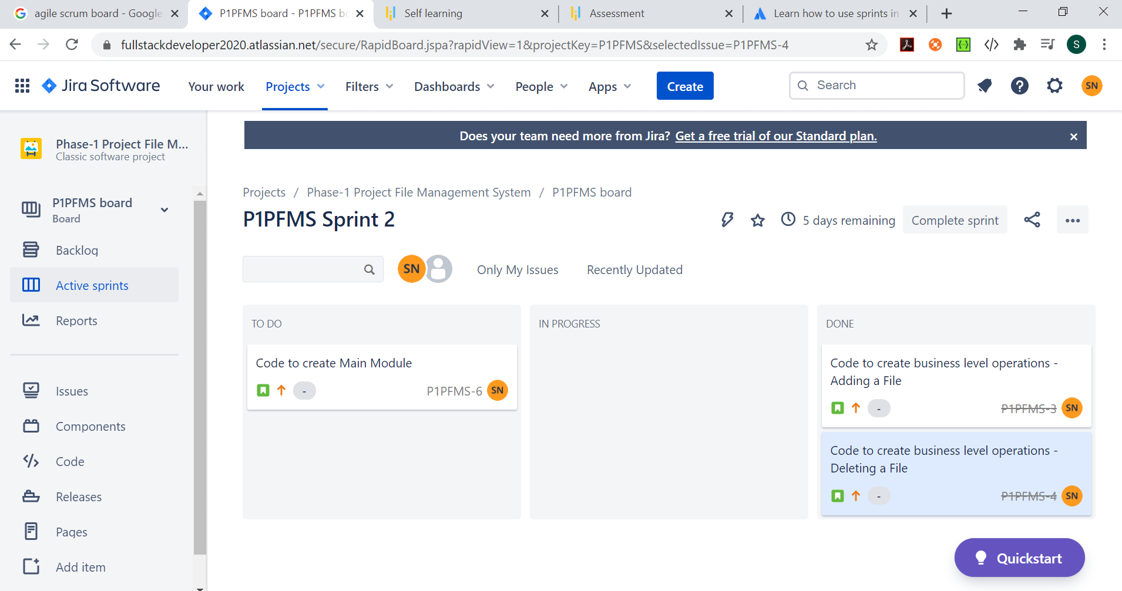

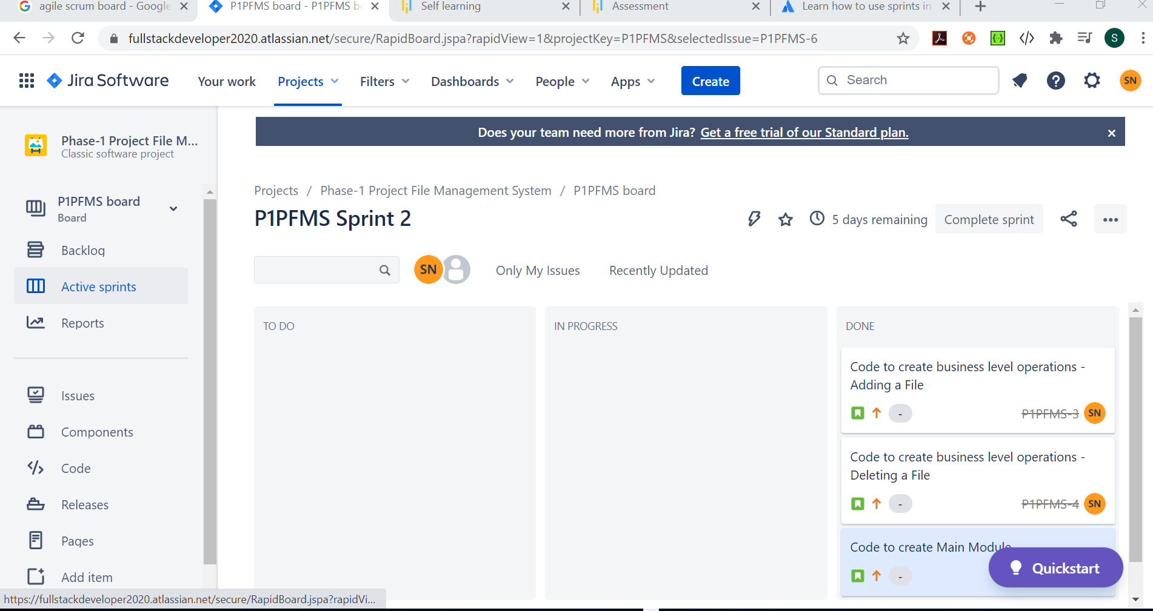

**Flow of Application and Flow Chart:**

**Steps to open the project:**

* My Project name is project_phase1.
* In src folder, created a package name lockedme.
* Navigate to Main.java file to start execution of application

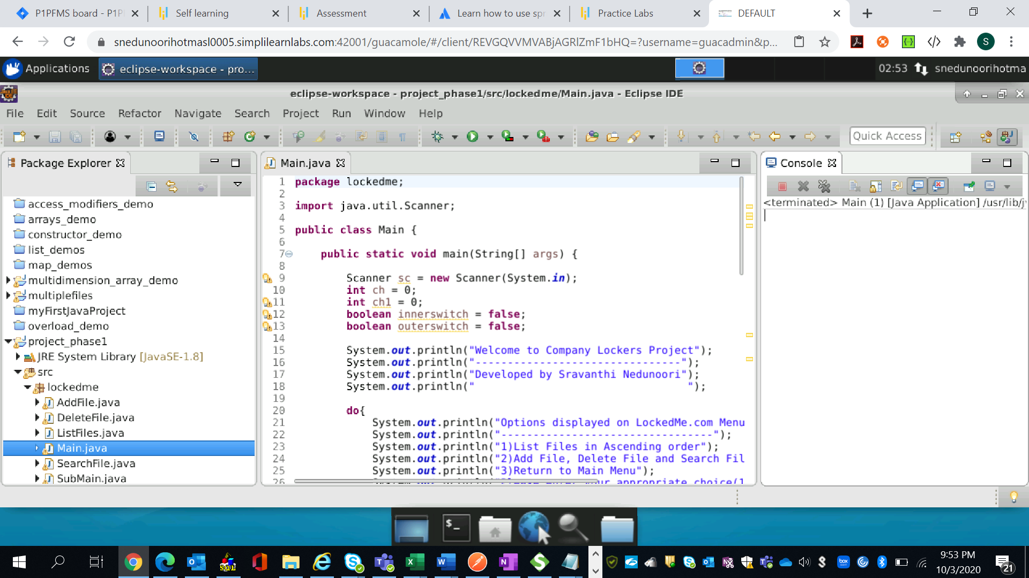

When user enters the application, I used switch case to enable user different options and instantiated objects and their respective methods. User will be presented with 3 options as below:

1. List Files in Ascending Order
2. Add File, Delete File and Search File
3. Return to Main Menu

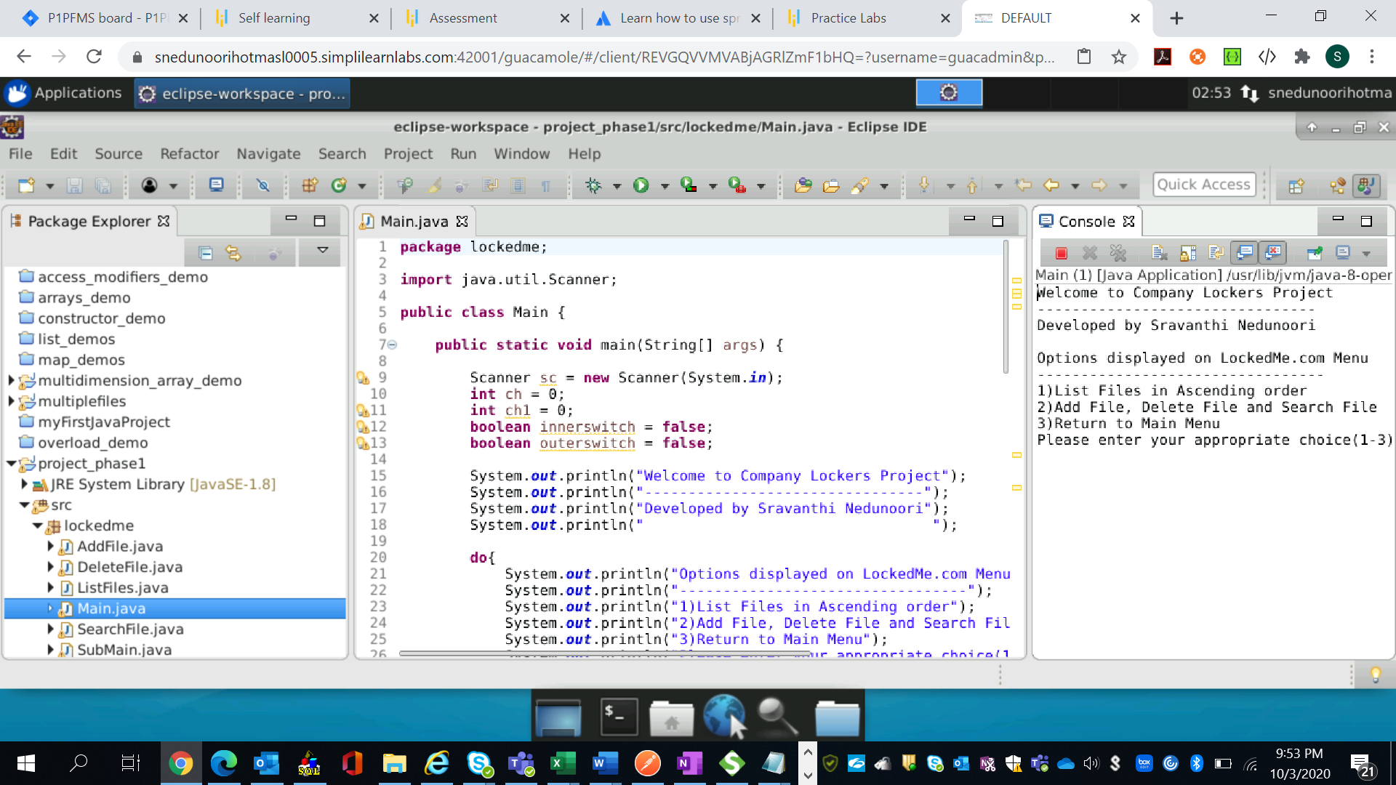

Please enter your appropriate choice (1-3)

* When user chooses to enter option 1: This option lists all the files in root directory in Ascending Order

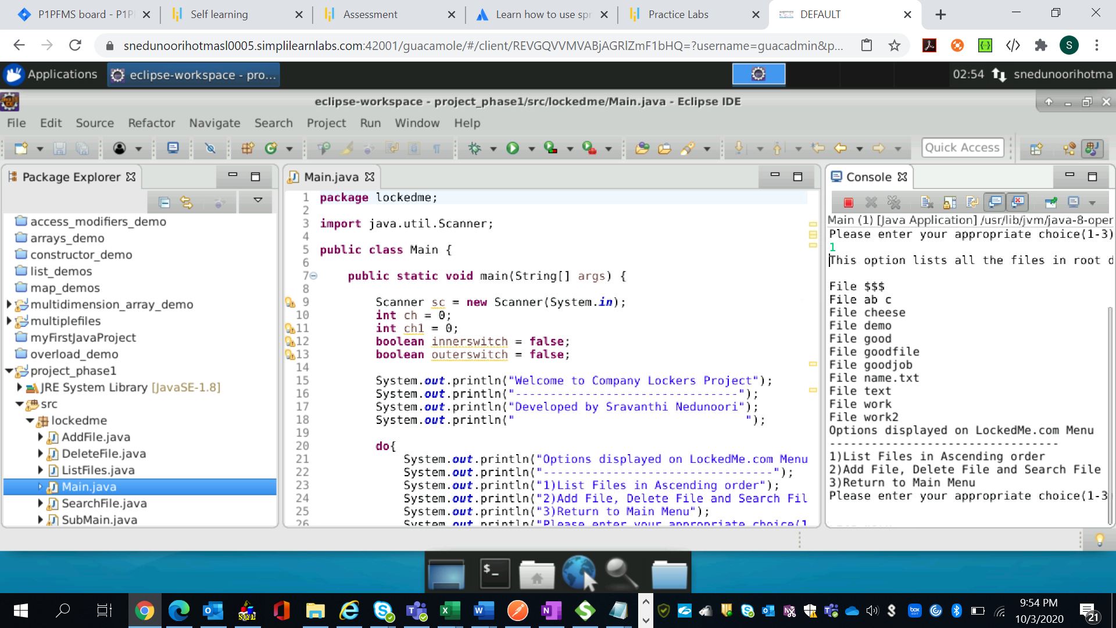

* When user chooses to enter option 2: This option provides user to input various business level operations

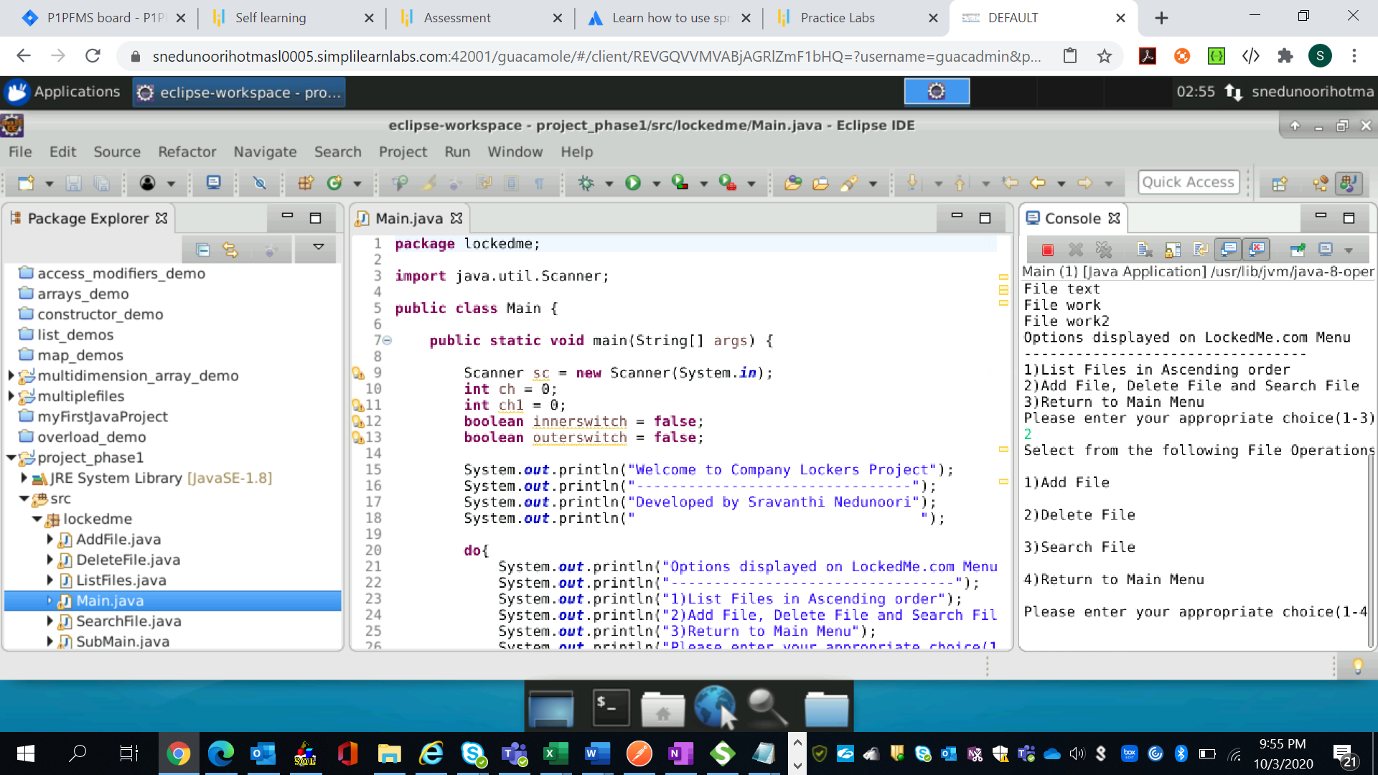

* Business Level Operations provides user with Adding a file, deleting a file, searching a file and return to main menu options. Now the user can choose any of the above-mentioned options. This code is also developed using Switch case and calling respective functions in the sub main class
* For instance, user enters input as Option 1, this option asks the user to add a file into the root directory

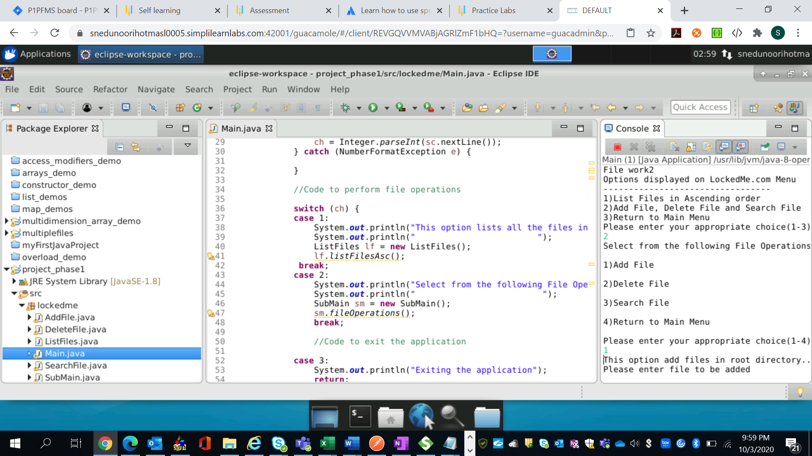

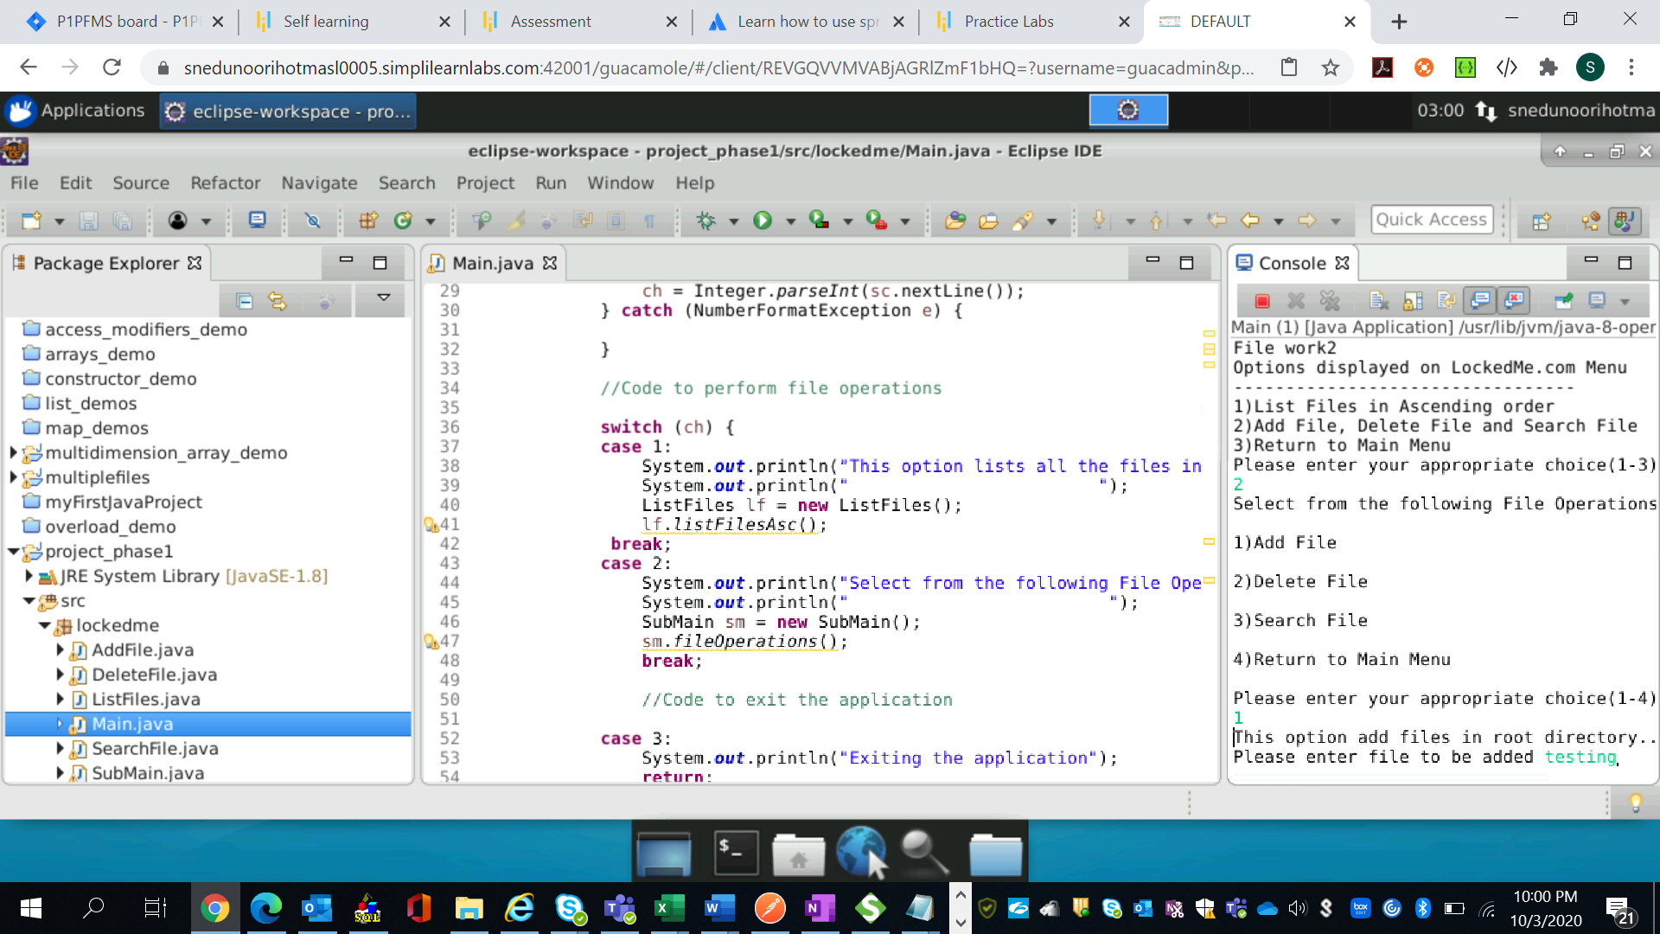

Then response will be printed as file saved. Upon refreshing the root directory you will see the newly added file

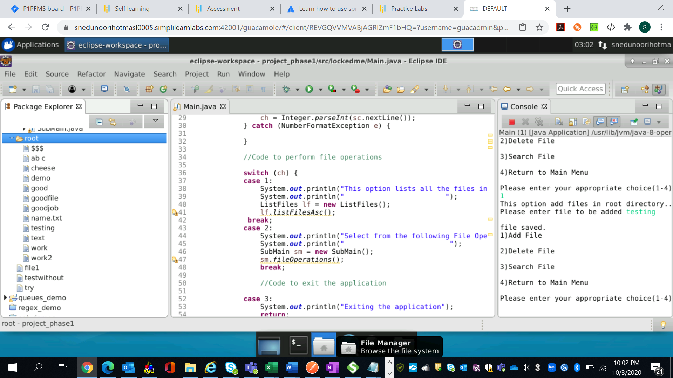

* If user selects option 2: User will be presented with an option to delete a file

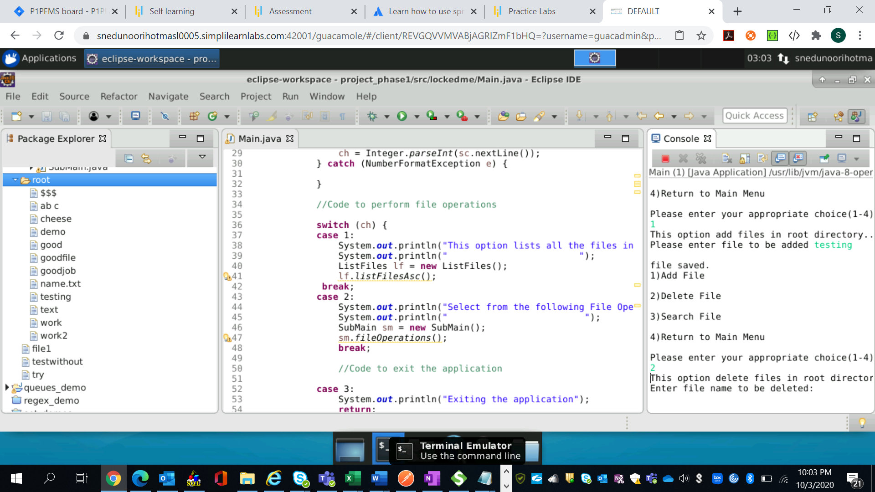

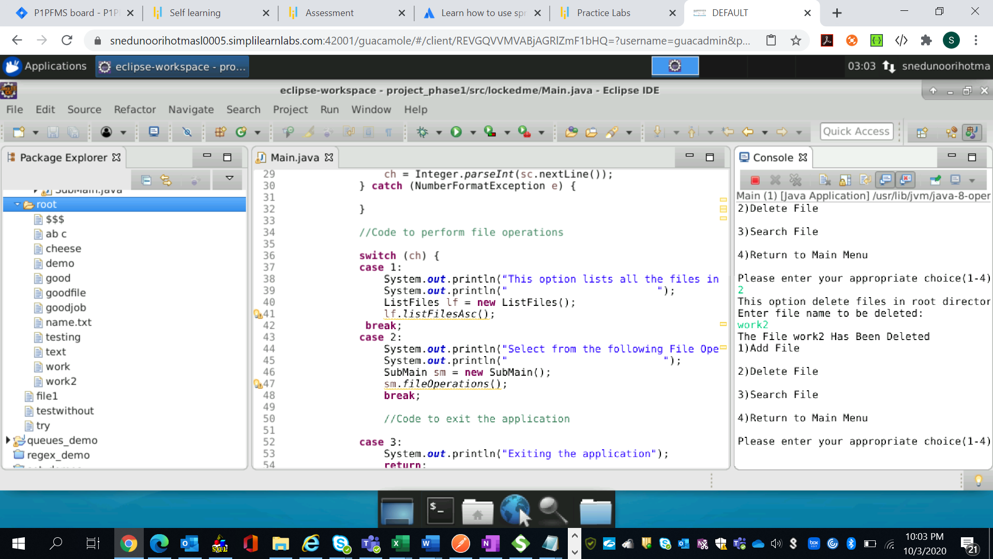

* If user chooses Option 3: User will be provided with an option to search for a file in the root directory

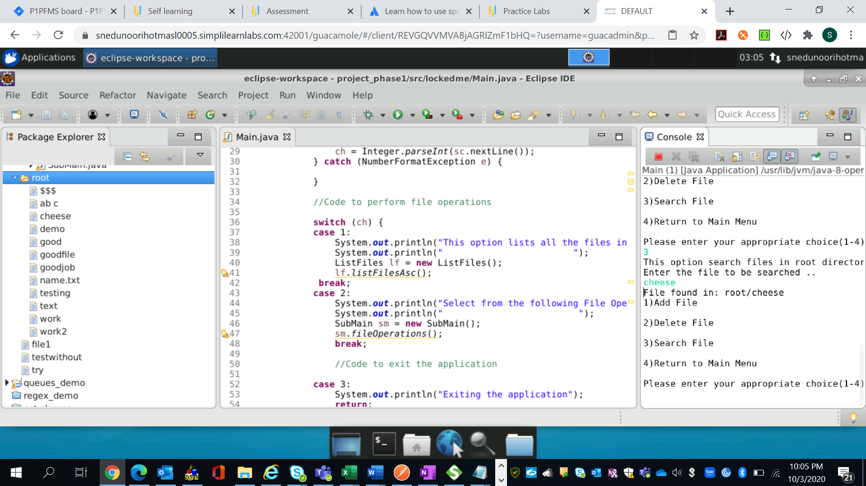

* If user chooses Option 4: User will be routed to Main Menu

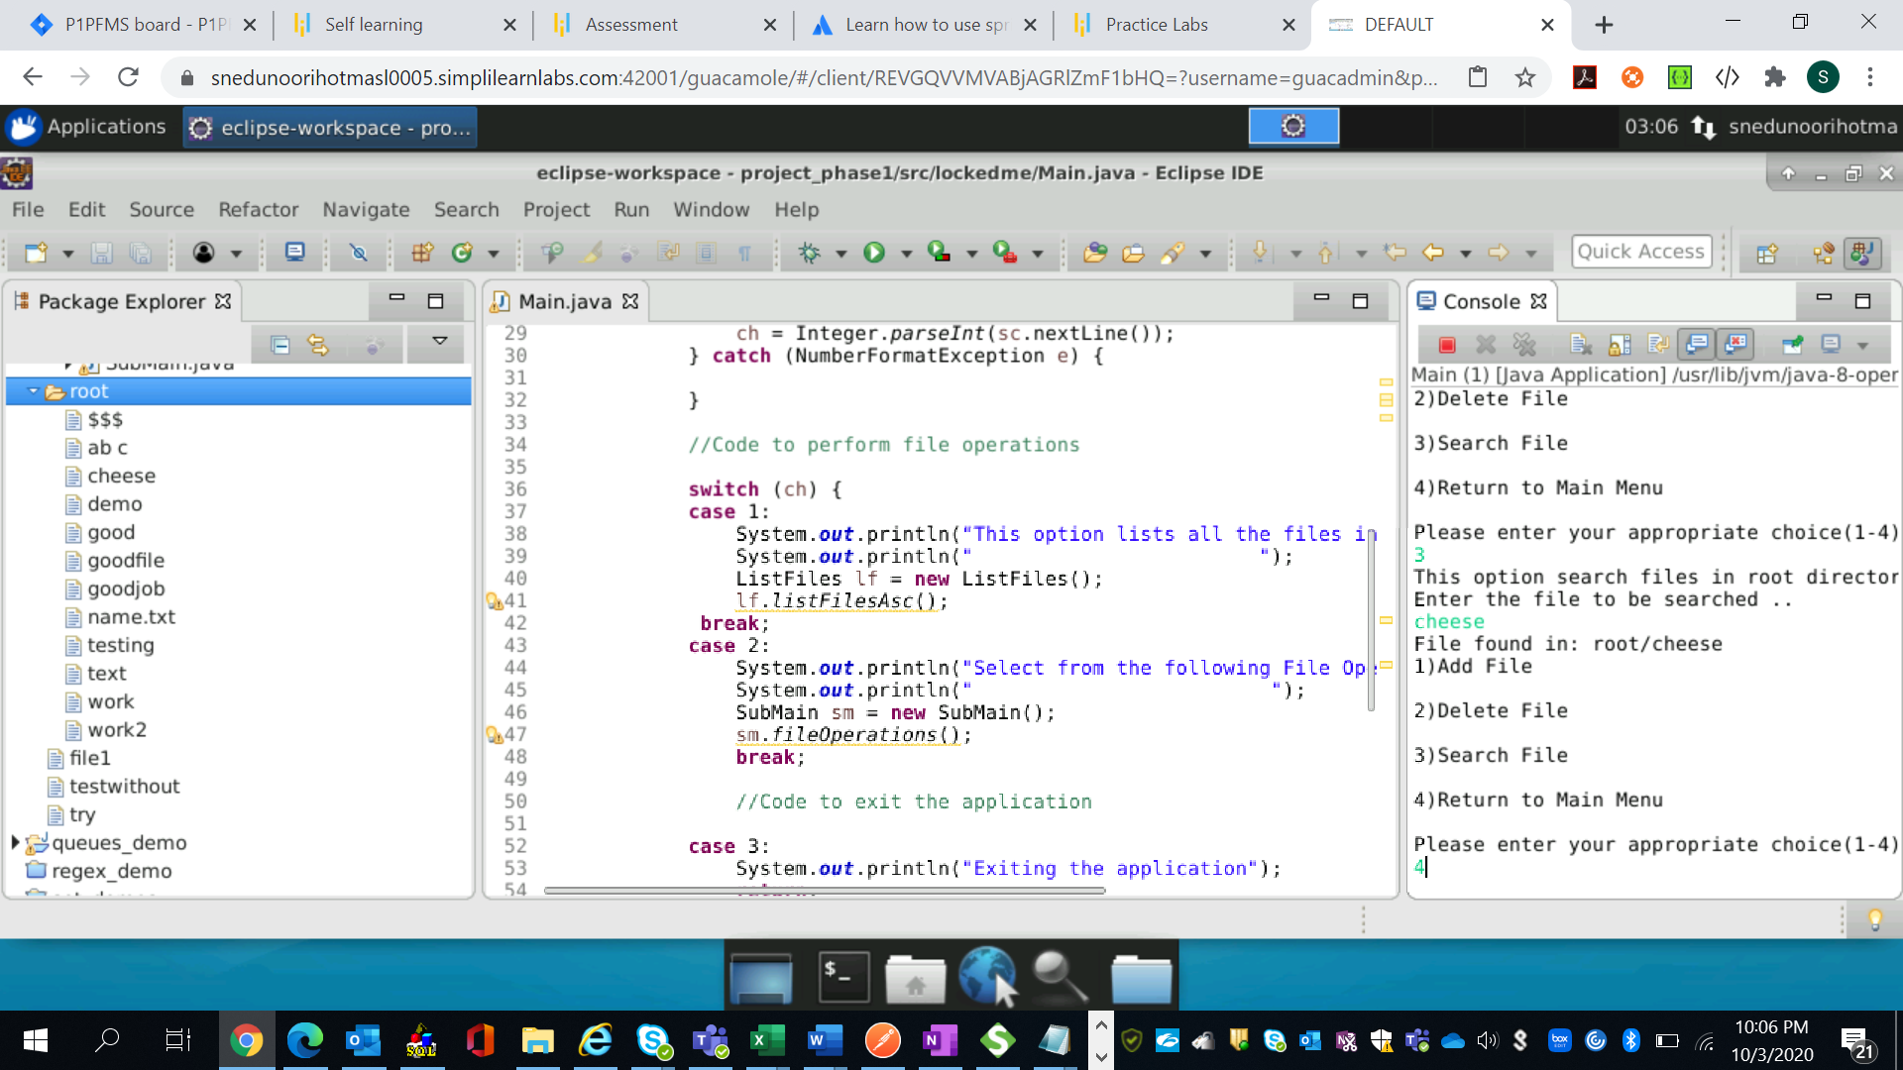

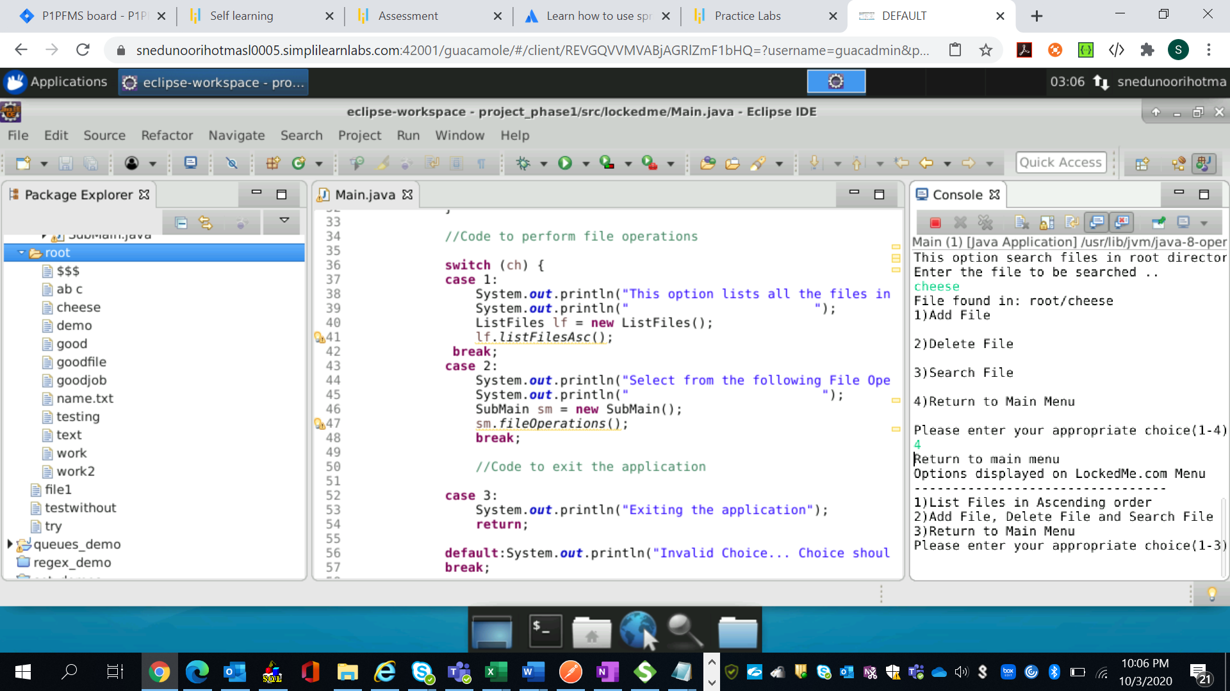

* Once the user chooses to return back to main menu, user can also exit application by selecting option 3 :

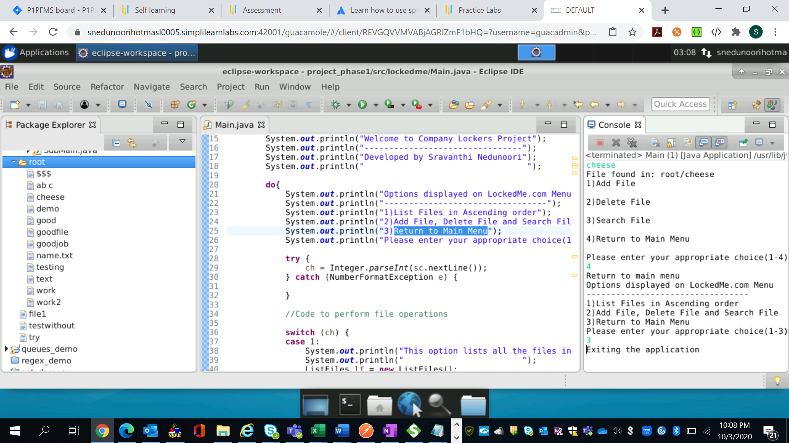

**Modules Explanation:**

**Main.java** – Consists of Switch case along with Do-while loop in order to enable user with different options to navigate through the application. I created sub modules for each function in this class and created a object and initiated a method associated with the object. Here, I used OOPS concept to develop this modularity function

**ListFiles.java** – Used new File command to create a file in the root directory. Since this root directory consists of several files, created an Array object to return the list of files in the root directory.

Used Arrays.sort collections functionality for sorting arrays in ascending order, by default Arrays.sort returns result set in ascending order.

**AddFiles.java** – This option is used to add a file to the root directory. Included Scanner input, so user can choose to enter a file name to be entered in the root directory. Used createnewFile method to create a new file into the root directory. Then handled any file exception using IO exception

**DeleteFile**.java – This option enables user to delete a file from root directory. Used delete method on file that needs to be deleted.

**SearchFile**.java – This option enables user to search for a file in root directory. Used for each loop to list all the files in the root directory. Also used equalsIgnorecase method on the filename.

**SubMain**.java – Consists of switch case along with Do-while loop to loop through the business level operations.

**FlowChart:**

Start

A

Display Menu

Input Choice

While choice is not 3

End

Switch choice

Choice 3: Exit Application

Choice 2: Business Level

Operations

Choice 1 - List Files

While choice is not equal to 4

Switch choice

Choice 3 -Search Files

A

Choice 2 - Delete Files

Choice 1 - Add Files

Choice 4- Return to Main Menu

**Enhancing Application and USP’s:**

**USP’s**

* Handled all the exception flows.
* Modularized the application for easy debug and clean readability
* Used simple functions to execute different business level operations
* Added comments to help the user navigate through the code

**Enhancing Application:**

In order to enhance this application, we can make it more user experience friendly by creating a UI application by adding buttons, user login ability, user registration ability, adding more different file types and performing more file operations by including content in the file.